#### SIDDAGANGA INSTITUTE OF TECHNOLOGY, TUMAKURU-572103

**(An Autonomous Institute under Visvesvaraya Technological University, Belagavi)**



**Project Report on**

**“IOT Based Agricultural Motor Starter Controller”**

submitted in partial fulfillment of the requirement for the completion of

VI semester of

**BACHELOR OF ENGINEERING**

**in**

**ELECTRONICS & TELECOMMUNICATION ENGINEERING**

**Submitted by**

ABHI CHANDRA N 1SI20ET001 HARSHA K R 1SI20ET019

YOJITH K R 1SI20ET052 RITHESH KUMAR H D 1SI21ET400

Under the guidance of

Dr. K C Narasimhamurthy Professor

Telecommunication Engineering [kcnmurthy@gmail.com](mailto:kcnmurthy@gmail.com)

**DEPARTMENT OF ELECTRONICS & TELECOMMUNICATION ENGINEERING**

SIDDAGANGA INSTITUTE OF TECHNOLOGY

(An Autonomous institution, affiliated to VTU, Belgaum, Recognized by AICTE, Accredited by National Board of accreditation, New Delhi)

DEPARTMENT OF ELECTRONICS AND TELECOMMUNICATION ENGINEERING



CERTIFICATE

This is to certify that the Mini project entitled **“IOT Based Agricultural Motor Starter Controller**” is a bonafide work carried out by ABHI CHANDRA N **(**1SI20ET001**)**, HARSHA K R **(**1SI20ET019**)**, YOJITH K R **(**1SI20ET052**)** and RITHESH KUMAR H D **(**1SI21ET400**)** in partial fulfillment of the requirement of the award of the degree in B.E, Electronics and Telecommunication Engineering, Visvesvaraya Technological University, Belagavi during the academic year 2022-2023. It is certified that all corrections/suggestions indicated for internal assessment have been incorporated in the report. The project report has been approved as it satisfies the academic requirements in respect of project work prescribed for the Bachelor of Engineering Degree

|  |  |
| --- | --- |
| **Dr. K VISHWANATH** | **Dr. K C NARASIMHAMURTHY** |
| Professor and Head | Associate Professor |
| Dept. of ETE | Dept. of ETE |
| SIT, Tumakuru | SIT, Tumakuru |

|  |  |
| --- | --- |
| **Name of the Examiners** | **Signature with Date** |
| **1.** |  |
| **2.** |  |

**ACKNOWLEDGEMENT**

I consider this a privilege to express few words of gratitude to all those who guided and inspired me for the successful completion of our mini project.

With respectful pranamas to His Holiness **Dr. Sree Sree ShivakumaraSwamigalu, Sree SiddalingaSwamigalu** President, Sree Siddaganga Education society, I express my gratitude at his lotus feet for being a constant source of inspiration in the course of study.

With gratitude I acknowledge our beloved director **Dr. M. N. Channabasappa**, **, Ph.D**, CEO **Dr. Shivakumaraiah**, Ph.D. and principal **Dr.S V Dinesh** for fostering an excellent lab facilities , which made our endeavour possible.

I express my deep sense of gratitude to our guide **Dr. K C Narasimhamurthy**, Professor , Department, Electronics and Telecommunication Engineering, who has always been a remarkable source of inspiration whose unflagging zeal has catalyzed us to strive for greater heights during the span of course in this Institution.

Finally, we would like to thank all the faculty and non-teaching staff members Department of Electronics and Telecommunication Engineering and our parents and friends, without whose help and constant encouragement, it would have been difficult for me to complete this project.

ABHI CHANDRA N 1SI20ET001 HARSHA K R 1SI20ET019 YOJITH K R 1SI20ET052

RITHESH KUMAR H D 1SI21ET400

**2022-23**

DECLARATION

We, ***Abhi chandra N (1SI20ET001),HARSHA K R (1SI20ET019),YOJITH K R***

***(1SI20ET052),and RITHESH KUMAR H D (1SI21ET400)*** hereby declare that the project entitled that the “**IOT BASED AGRICULTURAL MOTOR STARTER COTROLLER** ” is a bonafide work carried out by us under the guidance of **Dr. K C Narasimhamurthy**, Professor, Department of Electronics and Telecommunication Engineering, Siddaganga Institute of Technology, Tumkur is being submitted in partial fulfilment of the requirements for completion of Mini project work in the program of study of B.E., Electronics and Telecommunication Engineering. This work has not been submitted to any other university.

#### Names Signature

**ABHI CHANDRA N (1SI20ET001) HARSHA K R (1SI20ET019)**

#### YOJITH K R (1SI20ET052) RITHESH KUMAR H D (1SI21ET400)

**PLACE: TUMAKURU DATE:**

# Contents

Abstract 1

1. Introduction
   1. Motivation 2

1.2 Objective of the project . . . . . . . . . . . . . . . . . . . . . . . . . . . . 2

1. Literature Survey . . . . . . . . . . . . . . . . . . . . . . . . . . . . . . . . . . . . . . . . . . . . . . . . . 3
2. Methodology . . . . . . . . . . . . . . . . . . . . . . . . . . . . . . . . . . . . . . . . . . . . . . . . . 4

3.1 Block Diagram . . . . . . . . . . . . . . . . . . . . . . . . . . . . . . . . . . 4

1. System Hardware . . . . . . . . . . . . . . . . . . . . . . . . . . . . . . . . . . . . . . . . . . . . . . . . . . . . 5

Fig: A ESP32 micro-controller . . . . . . . . . . . . . . . . . . . . . . . . . 5

Fig: B Relay 30A . . . . . . . . . . . . . . . . . . . . . . . . . . . . . . . . . . 5

Fig: C Current Transformer Sensor . . . . . . . . . . . . . . . . . . . . . . . . . 6

Fig: D L293D Relay Module . . . . . . . . . . . . . . . . . . . . . . . . . 6

1. Implementation . . . . . . . . . . . . . . . . . . . . . . . . . . . . . . . . . . . . . . . . . . . . . . . . . 7
2. Flow Chart . . . . . . . . . . . . . . . . . . . . . . . . . . . . . . . . . . . . . . . . . . . . . . . . . 8
3. System Software 9
   1. Arduino IDE . . . . . . . . . . . . . . . . . . . . . . . . . . . . . . . . . 9

7.2 Firebase . . . . . . . . . . . . . . . . . . . . . . . . . . . . . . . . . . .9

1. Results 10

8.1 Snapshots. . . . . . . . . . . . . . . . . . . . . . . . . . . . . . . . . . . . 11

1. Conclusion 12

9.1 Scope for future . . . . . . . . . . . . . . . . . . . . . . . . . . . . . . . . . 12

9.2 References. . . . . . . . . . . . . . . . . . . . . . . . . . . . . . . . . . . 12

Appendices 13

A Key Specifications of Texmo Taro Pumps 13

# Abstract

Most of the agriculture lands in India are highly productive but the problem lies in irrigation. Irrigation plays a dominant role in agriculture most of the productive lands use ground water irrigation since there is no proper rainfall in present situations. Ground water irrigation have a basic need, that is electricity, With this irregular power cuts it is very difficult to control agricultural motors manually, So to overcome this problem we need to utilize electricity whenever it is present.

Especially if farming land is at a distant point from farmers place then its difficult for the farmer to control the agricultural motor

Our project provides Remote access facility for farmers to control their submersible motor pumpsover internet from anywhere in the world.

Our module provides voltage and current protection so that the motor is not affected by the voltage and current fluctuations.The motor will be protected from Dry run

During the functioning of the motor , if it is affected by fluctuations in voltage or current and if voltage or current drawn are not within the specified range then the motor will be turned off and the status of the motor is updated to the cloud. The system takes the necessary action based on the more specified by the user, Hence protecting the motor from winding damage

# 1. Introduction

## Motivation

We noticed that in most of the cases the crop-fields are located far away from thefarmer's residence. Farmers have to travel significant distances to go to their crop fields for controlling the motor.

Due to severe voltage fluctuations motors were prone to winding damages which would cost a lot to farmers to repair the motors. Farmers needs to lift the motors from the tubewells and must repair them and their put back again which includes a lot of risk and money.

Due to improper rain and less water in borewells motors undergo dry run which would cause damage to winding

## Objective of the project

Providing an easy, remote monitoring and control of the motors which can be done from anywhere in the world through Firebase cloud interface.

Automating the starting and stopping of agricultural motors to improve efficiency and reduce the need for manual labor.

Providing real-time data and remote access to the motor's status and performance ,allowing farmers to make informed decisions about their operations.

Providing protection to the motor from voltage fluctuations and dry run

Monitoring and controlling the motor's performance and usage to optimize energy consumption and reduce costs.

Improving the overall productivity and yield of the agricultural operations by automating motor control

As many of the farmers irrigate even at night, their lives can be saved from wild animals

# 2. Literature Survey

**7**

**Existing Methodology**

*Internet of things (IoT) is a promising technology which provides efficient and reliable solutions towards the modernization of several domains. IoT based solutions are being developed to automatically maintain and monitor agricultural farms with minimal human involvement.Over the years,several methodologies have been developed to tackle this problem. Here are some of the existing methodologies for IOT Based Agricultural Motor Starter Controller:*



### [1] L. Zhang, I. K. Dabipi and W. L. Brown, "Internet of Things applications for agriculture" in Internet of Things A to Z: Technologies and Applications, 2018:

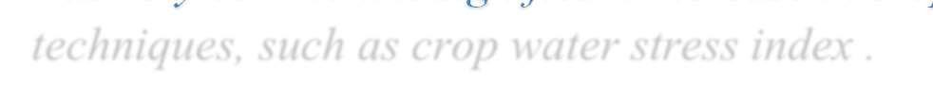

*This paper provides a comprehensive survey of the main reason for this high water consumption is the monitoring procedure as even in 2013, crops visual inspection for irrigation decision-making was very common. A significant increase in crop efficiency is expected with the use of IoT based techniques, such as crop water stress index .*

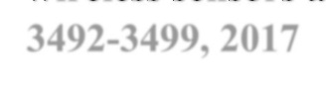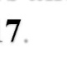

**[2] S. Navulur and M. N. Giri Prasad, "Agricultural management through wireless sensors and Internet of Things", Int. J. Elect. Comput. Eng., vol. 7, pp. 3492-3499, 201** .

*This paper provides the need of smart agriculture arises, as 70% of farming time is spent monitoring and understanding the crop states instead of doing actual field work .This is done by measuring rainfalls, stream flows, and other water presence options.*

1. **J. Lin, W. Yu, N. Zhang, X. Yang, H. Zhang and W. Zhao, "A survey on Internet of things: Architecture enabling technologies security and privacy and applications", IEEE Internet Things J., vol. 4, no. 5, pp. 1125-1142, Oct. 2017.**



*This paper deals with the recognition of the Internet-of-Things (IoT) is beginning to impact a wide array of sectors and industries, ranging from manufacturing, health, communications, and energy to the agriculture industry, in order to reduce inefficiencies and improve the performance across all markets.*

# 3. Methodology

**Firebase Cloud**

**3-phase AC Supply 440V,50Hz**

**Sampling AC voltage**

**Motor Controller**

**Motor**

**MICRO CONTROLLER**

**Current Sensor**

Fig 3.1: Block Diagram

Three phase AC 440V 50Hz power supply is provided to AC sampling circuit. The sampling circuit consists of a 6-0-6 step down transformer which has a sine wave peak of 6V. Sampling circuit consists of a voltage divider circuit to reduce the Sine wave peak to 3.3V.

6V peak sine wave from step down transformer is sampled in a in such a way that the sine wave swings in between 0 to 3.3V , so that microcontroller can sample the voltages

Current transformer sensor is a split core sensor clamped onto one of the 3 phase mains given to input of starter to measure current drawn by the motor.

To control the motor from the microcontroller the L293D driver module is interfaced with relays. The relays are further connected to start push button and stop push button of the starter to control the motor.

# 4. System Hardware

The hardware components used in this proposed system are:

* 1. ESP32 micro-controller
  2. Relay 30A
  3. Current Transformer Sensor
  4. L293D Relay Module

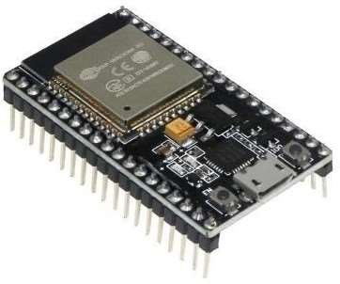

Fig A: ESP32 micro-controller

ESP32 is a low-cost, low-power microcontroller with built-in Wi-Fi and Bluetooth. It is widely used in IoTprojects and can be programmed using Arduino IDE or ESP-IDF. It has low power consumption, high processing power, and high connectivity capabilities, making it popular for IoT and home automation projects .

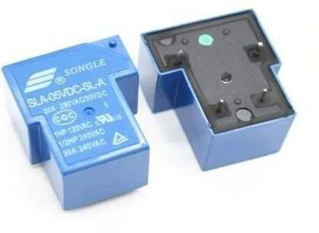

Fig B: RELAY 30A

A 12 volt 30 amp relay is an electronic switch that is activated by a small electrical current. It uses an electromagnet to open or close a switch, allowing a larger current to flow through it. It is rated for 12V DC and can handle up to 30A. It can be used in automotive systems, lighting, and HVAC systems, to control high-current circuits with low-current signals and to isolate different circuits from one another.

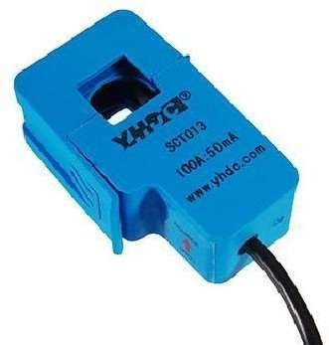

Fig C: SCT013-050 Split core current transformer

Step down transformer is used to step down the AC voltage and it is rectified using bridge rectifier and a shottkey diode is used to limit the voltage to 3.3 volt to prevent the damage to ESP32, now the AC voltage can be measuredand monitored with ESP32

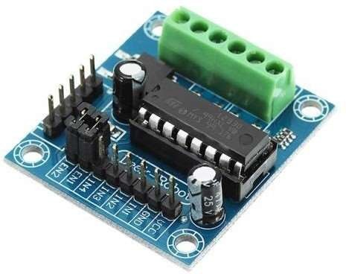

Fig D: L293D Relay Module

The L293D is a popular motor driver module designed to control and drive small to mediumsized DC motors. It supports bidirectional control for two motors, providing convenient control over speed and direction using input signals from a microcontroller. With built-in protection features, the L293D is commonly used in robotics, automation, and electronics projects requiring precise motor control.

## 5. Implementation

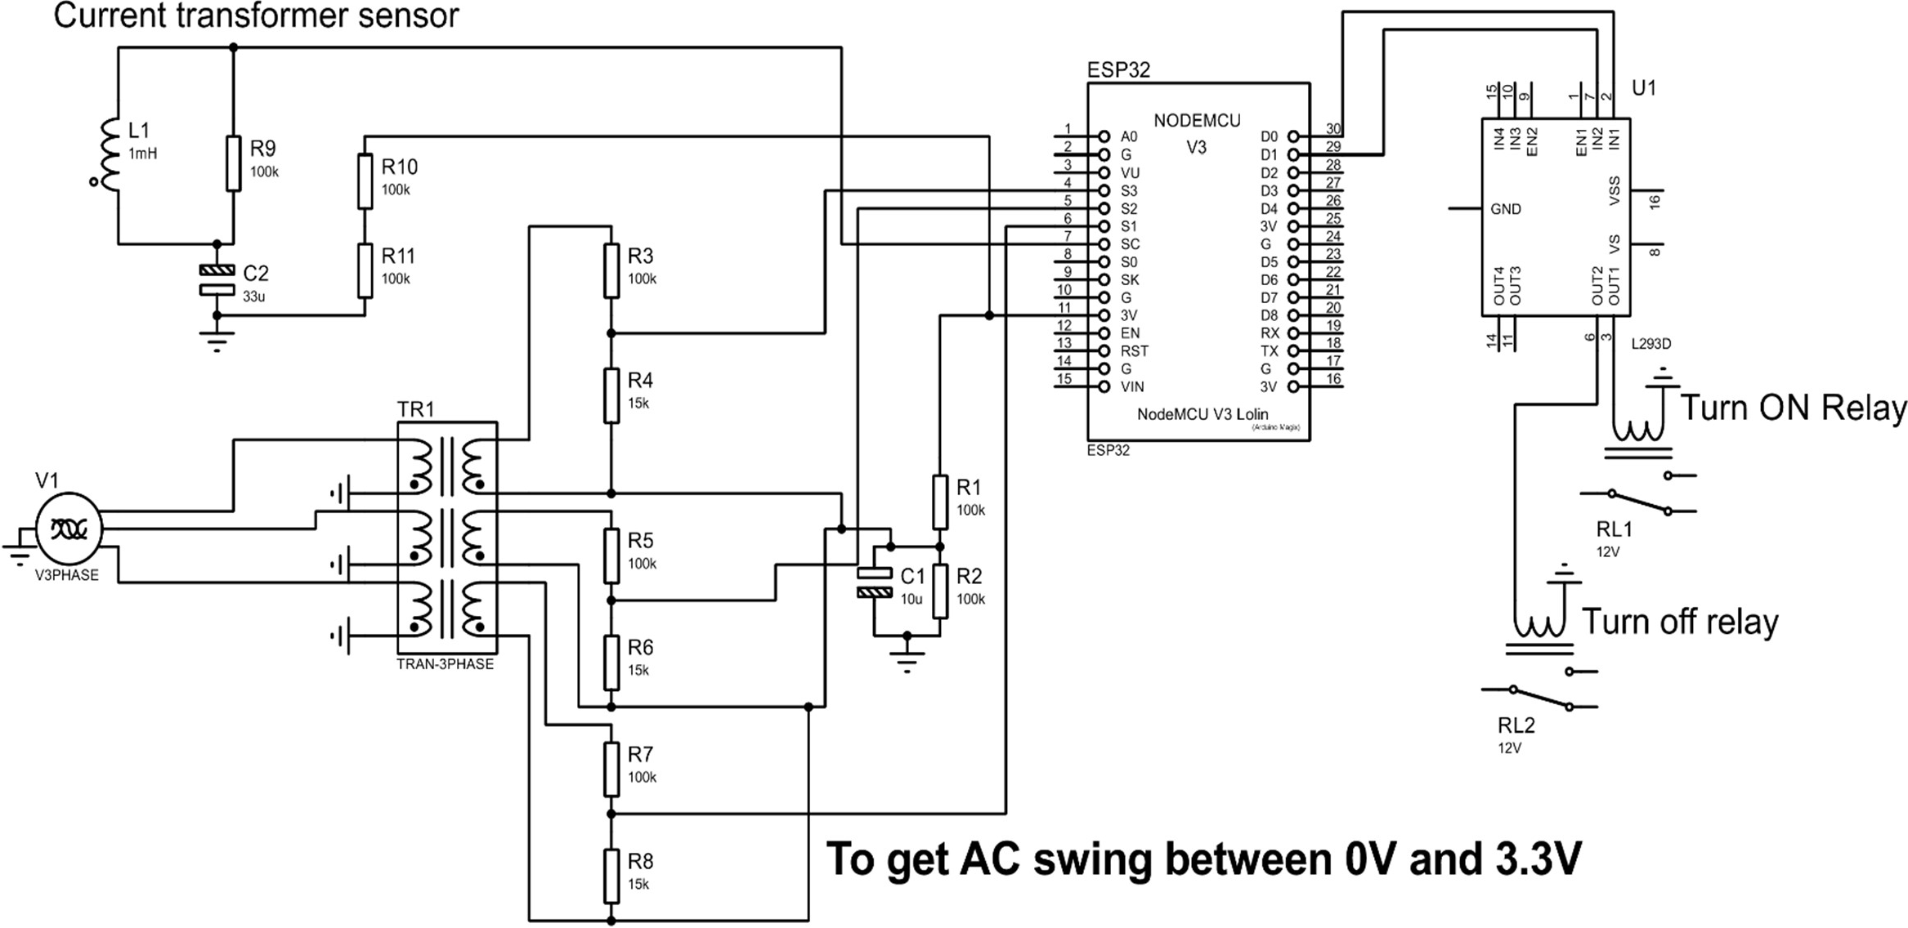

The AC 3 phase power supply is a 440V , 50 Hz supply

Each phase is connected to a 6-0-6 step down transformer, then further connected to voltage divider circuit which restricts the peak 6V peak to 2.4V

The voltage divider circuit is provided with 1.65V offset so that the resulting sine waves wings in between 0V to 3.3V, Hence the ESP 32 microcontroller can sample the Sine wave using the inbuilt ADC

The current transformer sensor is clamped onto one of the three phase AC mains connected to input of the starter

The current sensor outputs 1V peak sine wave for 50A current passing through the sensor .

1.65V offset is provided to sine wave from current transformer so that the resulting signals swings in between 0 to 3.3V hence ESP 32 can sample the Sine wave readings

L293D relay module is used to interface 12V, 30A relays with ESP32 to control the Motor

Department of ETE, SIT, Tumakuru Page 7 2022-23

# 6. Flowchart:

Start

Auto Mode

Manual Mode

If Voltage

Satisfy Threshold

Turn ON

DRYRUN

Detection

Turn OFF motor

Update DRYRUN

to Firebase

Check 3-phase

Voltage

User can turn

ON or OFF

Motor Turn OFF

Turn ON

Check Voltages

and Current

Turn OFF motor

Turn ON motor

True

False

Yes

No

Initially user is provided with two modes auto and manual mode

In auto mode, System continiously senses AC voltage and if the voltage is within the threshold then the motor will be on, if the voltage doesn’t satisify threshold then the motor will be turned off but the system waits for the voltage to get constant and be within the threshold and then the motor will be turned on automatically

In case of manual mode , user is given privilege to control the motor based on his requirement ,when the motor is on, if the current goes off or voltage fluctuates then motor will be turned off, it will be off until the user himself takes necessary action

# 7. System Software

**About Software Requirements**

**7.1 Arduino IDE**

The Arduino Integrated Development Environment (IDE) is a user- friendly software platform designed for programming and developingprojects using Arduino microcontrollers. It provides a streamlined interface for writing, compiling, and uploading code to Arduino boards, enabling both beginners and experienced developers to createa wide range of electronic projects with ease. With its libraries and tools, Arduino IDE facilitates seamless hardware-software integration, making it a cornerstone for prototyping and experimenting in the world of embedded electronics. Fig

## 7.2 Firebase

Firebase IoT Cloud is a robust and scalable platform by Google that empowers developers to build and manage Internet of Things (IoT) applications effortlessly. It offers a comprehensive suite of tools and services for real-time data synchronization, secure device connectivity, and cloud- based control of IoT devices. By enabling seamless integration and easy data management, Firebase IoT Cloud accelerates the development of connected applications and enhances the efficiency of IoT solutions.

## 7.3 Proteus Simulation Software

Proteus is a versatile electronic design automation software that enables engineers and students to simulate, design, and test electronic circuits and microcontroller-based projects. With its intuitive interface and extensive component library, Proteus facilitates virtual prototyping, aiding in debugging and optimization before physical implementation. It's a valuable tool for both educational purposes and professional circuit design, offering a comprehensive environment for circuit simulation and system-level exploration.

# 8.Results

Providing real-time data and remote access to the motor's status and performance, allowing farmers to make informed decisions about their operations.

Automating the starting and stopping of agricultural motors to improve efficiency and reduce the need for manual labor.

As many of the farmers irrigate even at night, their lives can be saved from wild animals.

Preventing damages cause to winding of the 3-phase motor by protecting the motor from voltage fluctuations and single phase fault

Providing Dry run protection to the motor by monitoring the current drawn by the motor

Providing two modes for farmer to control the motor auto and manual mode

In manual mode farmer can turn on or turn off the motor as per the requirement of the farmer

If in case the power goes off in between, the motor will be turned off and it will not be turned on unless user specifies to do so.

In case of auto mode if the power goes off in between, then motor will be turned on immediately after the power arrives by checking the threshold voltages

Providing an easy, remote monitoring and control of the motors which can be done from anywhere through Firebase cloud interface.

Enhancing the safety of the agricultural operations by automating the process and reducing the risk of human error.

## 7.1 Snapshots

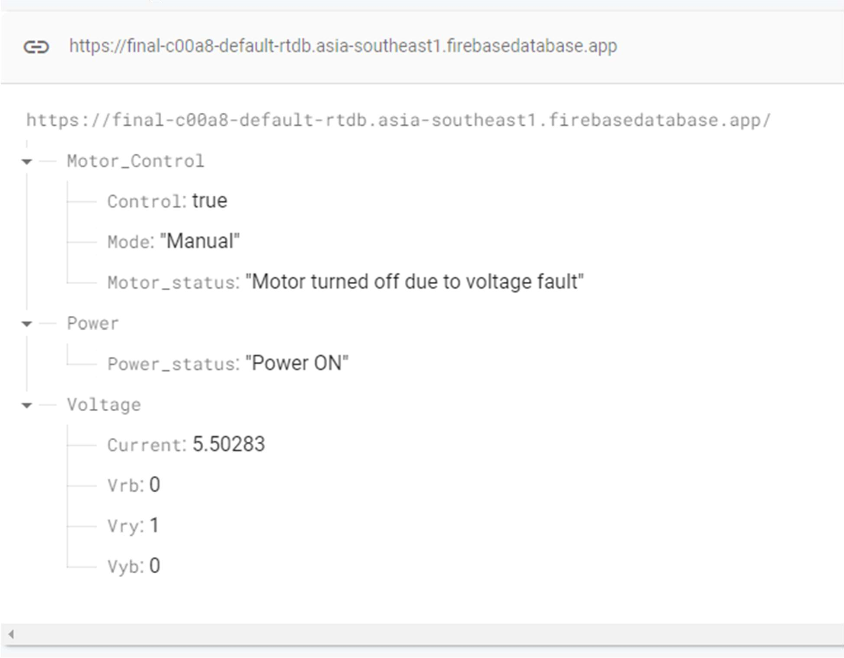

Fig 1: Firebase Realtime Database to control motor

* + - control variable is to accept data from user to turn on and turn off the motor
    - Mode gets input from user to set the mode of operation of the motor
    - Motor status indicator indicates the real time status of the motor
    - 3 phase voltages are displayed displayed by Vrb, Vyb and Vry respectively
    - The current drawn by the motor is displayed by current variable

# Conclusion

We got the practical experience about the problem faced by the farmer regarding agriculture motors and the problem faced by them in repairing those motors and starters which is risky, time consuming and money consuming.

We understood the difficulty of farmer who are at a distance places from their farmlands.

## Scope for future work

Integration of various smart devices and systems for seamless communication and automation, allowing users to control their entire farm ecosystem effortlessly.

Continued focus on energy-saving technologies to reduce electricity consumption, leading to cost savings and environmental benefits.

## References

1. Robu.in. [Online]. Available: https://robu.in/gsm-based-agriculture-motor-control-using-arduino- code/. [Accessed: 08-Aug-2023].
2. “Mobile phone motor starter,” Selkon.in. [Online]. Available: <http://www.selkon.in/mobile-phone-> starter.html. [Accessed: 08-Aug-2023].
3. Y. Engineers, “Farmers obedient motor starter – pinnaka Vinay Datta,” Yuvaengineers.com. [Online]. Available: <http://www.yuvaengineers.com/farmers-obedient-motor-starter-pinnaka-vinay-> datta/. [Accessed: 08-Aug-2023].
4. “How to load MicroPython on a microcontroller board,” Sparkfun.com. [Online]. Available: https://learn.sparkfun.com/tutorials/how-to-load-micropython-on-a-microcontroller-board/esp32-thing. [Accessed: 08-Aug-2023].
5. Taropumps.com. [Online]. Available: https://[www.taropumps.com/media/1610/ombw005a-seven-](http://www.taropumps.com/media/1610/ombw005a-seven-) inch-bws.pdf. [Accessed: 08-Aug-2023]

**Appendix**

# Key specifications

Standard Specification of 7 inch Borewell Submersible Pumps with 6 inch Submersible Motors is shownbelow in TABLE:

|  |  |
| --- | --- |
| Phase and Power | Three phase: 5 - 20 HP |
| Motor Type | Wet |
| Starting method | < 7.5HP: DOL |
| 7.5HP: DOL and SD Versions available |
| > 7.5HP: SD |
| Operating Voltage | Premium: 350 - 440 V  Power: 300 - 400 V |
| Frequency | 50 Hz |
| Speed | 2850 rpm |
| Duty | S1 Continuous |
| Max. Fluid  Temperature | 330C |
| Impeller Type | Mixed |
| Cable | 3 Core PVC Insulated flat cable |

* + According to the about data sheet provided by Texmo Taro ,we will set the appropriate voltages and current for the operation of 3-phase Submersible pumps

Reference : https://[www.taropumps.com/media/1610/ombw005a-seven-inch-bws.pdf](http://www.taropumps.com/media/1610/ombw005a-seven-inch-bws.pdf)